**The Library App**

**A Mini-Project Report**

**Under**

**Implementation of Technology**

***Submitted by***

**DishantKaushik B050**

**ZoherKachwala B048**

**Aayush Sharma B056**

***in partial fulfillment for the award of the degree***

***of***

**B.Tech.**

**IN**

**Computer Science**

**At**



**Mumbai,**

**April 2015**

**CERTIFICATE**

Dishant Kaushik B050, Zoher Kachwala B048 Aayush Sharma B056

A

A

Zo

This is to certify that the project entitled “The Library App” is the bonafide work carried out by **DishantKaushik, ZoherKachwala and Aayush Sharma** of B.Tech (Computer Engineering), MPSTME (NMIMS), Mumbai, during the IX trimester of the academic year 2014-15, in partial fulfillment of the requirements for the award of the Degree of Bachelors of Technology as per the norms prescribed by NMIMS. The mini-project work has been assessed and found to be satisfactory.

\_\_\_\_\_\_\_\_\_\_\_\_\_\_\_\_\_\_\_

Prof Poonam Gupta

\_\_\_\_\_\_\_\_\_\_\_\_\_\_\_\_\_\_\_\_\_\_\_ \_\_\_\_\_\_\_\_\_\_\_\_\_\_\_\_\_\_\_\_\_\_\_\_

Examiner 1 Examiner 2

\_\_\_\_\_\_\_\_\_\_\_\_\_\_\_\_\_\_\_\_\_\_\_\_

Dean

Dr. S.Y. Mhaiskar

DECLARATION

We **Dishant Kaushik, Zoher Kachwala and Aayush Sharma** B.Tech (Computer Engineering), semester- IV, understand that plagiarism is defined as anyone or combination of the following:

1. Un-credited verbatim copying of individual sentences, paragraphs or illustration (such as graphs, diagrams, etc.) from any source, published or unpublished, including the internet.

2. Un-credited improper paraphrasing of pages paragraphs (changing a few words phrases, or rearranging the original sentence order)

3. Credited verbatim copying of a major portion of a paper (or thesis chapter) without clear delineation of who did wrote what.

4. We have made sure that all the ideas, expressions, graphs, diagrams, etc., that are not a result of our work, are properly credited. Long phrases or sentences that had to be used verbatim from published literature have been clearly identified using quotation marks.

5. We affirm that no portion of my work can be considered as plagiarism and we take full responsibility if such a complaint occurs. We understand fully well that the guide of the seminar/ seminar report may not be in a position to check for the possibility of such incidences of plagiarism in this body of work.

Signature of the Students:

Name: \_\_\_\_\_\_\_\_\_\_\_ \_\_\_\_\_\_\_\_\_\_\_\_ \_\_\_\_\_\_\_\_\_\_\_

Roll No. \_\_\_\_\_\_\_\_\_\_\_ \_\_\_\_\_\_\_\_\_\_\_\_ \_\_\_\_\_\_\_\_\_\_\_

Place: Mumbai \_\_\_\_\_\_\_\_\_\_\_ \_\_\_\_\_\_\_\_\_\_\_\_ \_\_\_\_\_\_\_\_\_\_\_

Date: April 2015\_\_\_\_\_\_\_\_\_\_\_ \_\_\_\_\_\_\_\_\_\_\_\_ \_\_\_\_\_\_\_\_\_\_\_

**ACKNOWLEDGEMENT**

We will be failing in our duty if we do not acknowledge the assistances of several people involved in the preparation of our project. This project is an acknowledgment to the intensity, drive and technical competence of many individual who have contributed to it. We deem it as our personal duty to thank all those who proved indispensable in the completion of our project. It is our privilege to express thanks to our mentor Prof Poonam Gupta for providing us with important references and constantly helping us with our difficulties. We are also thankful to Prof Dhirendra Mishra, Head Of Computer Engineering Department, for constantly guiding us throughout the project. We are also thankful to our Dean Dr. S.Y. Mhaiskar for providing us the opportunity. We would also like to express our gratitude to our colleagues for their support and care as well as for helping us in all possible ways. We are also thankful for everyone’s aspiring guidance, invaluably constructive criticism and valuable advise during the project work.

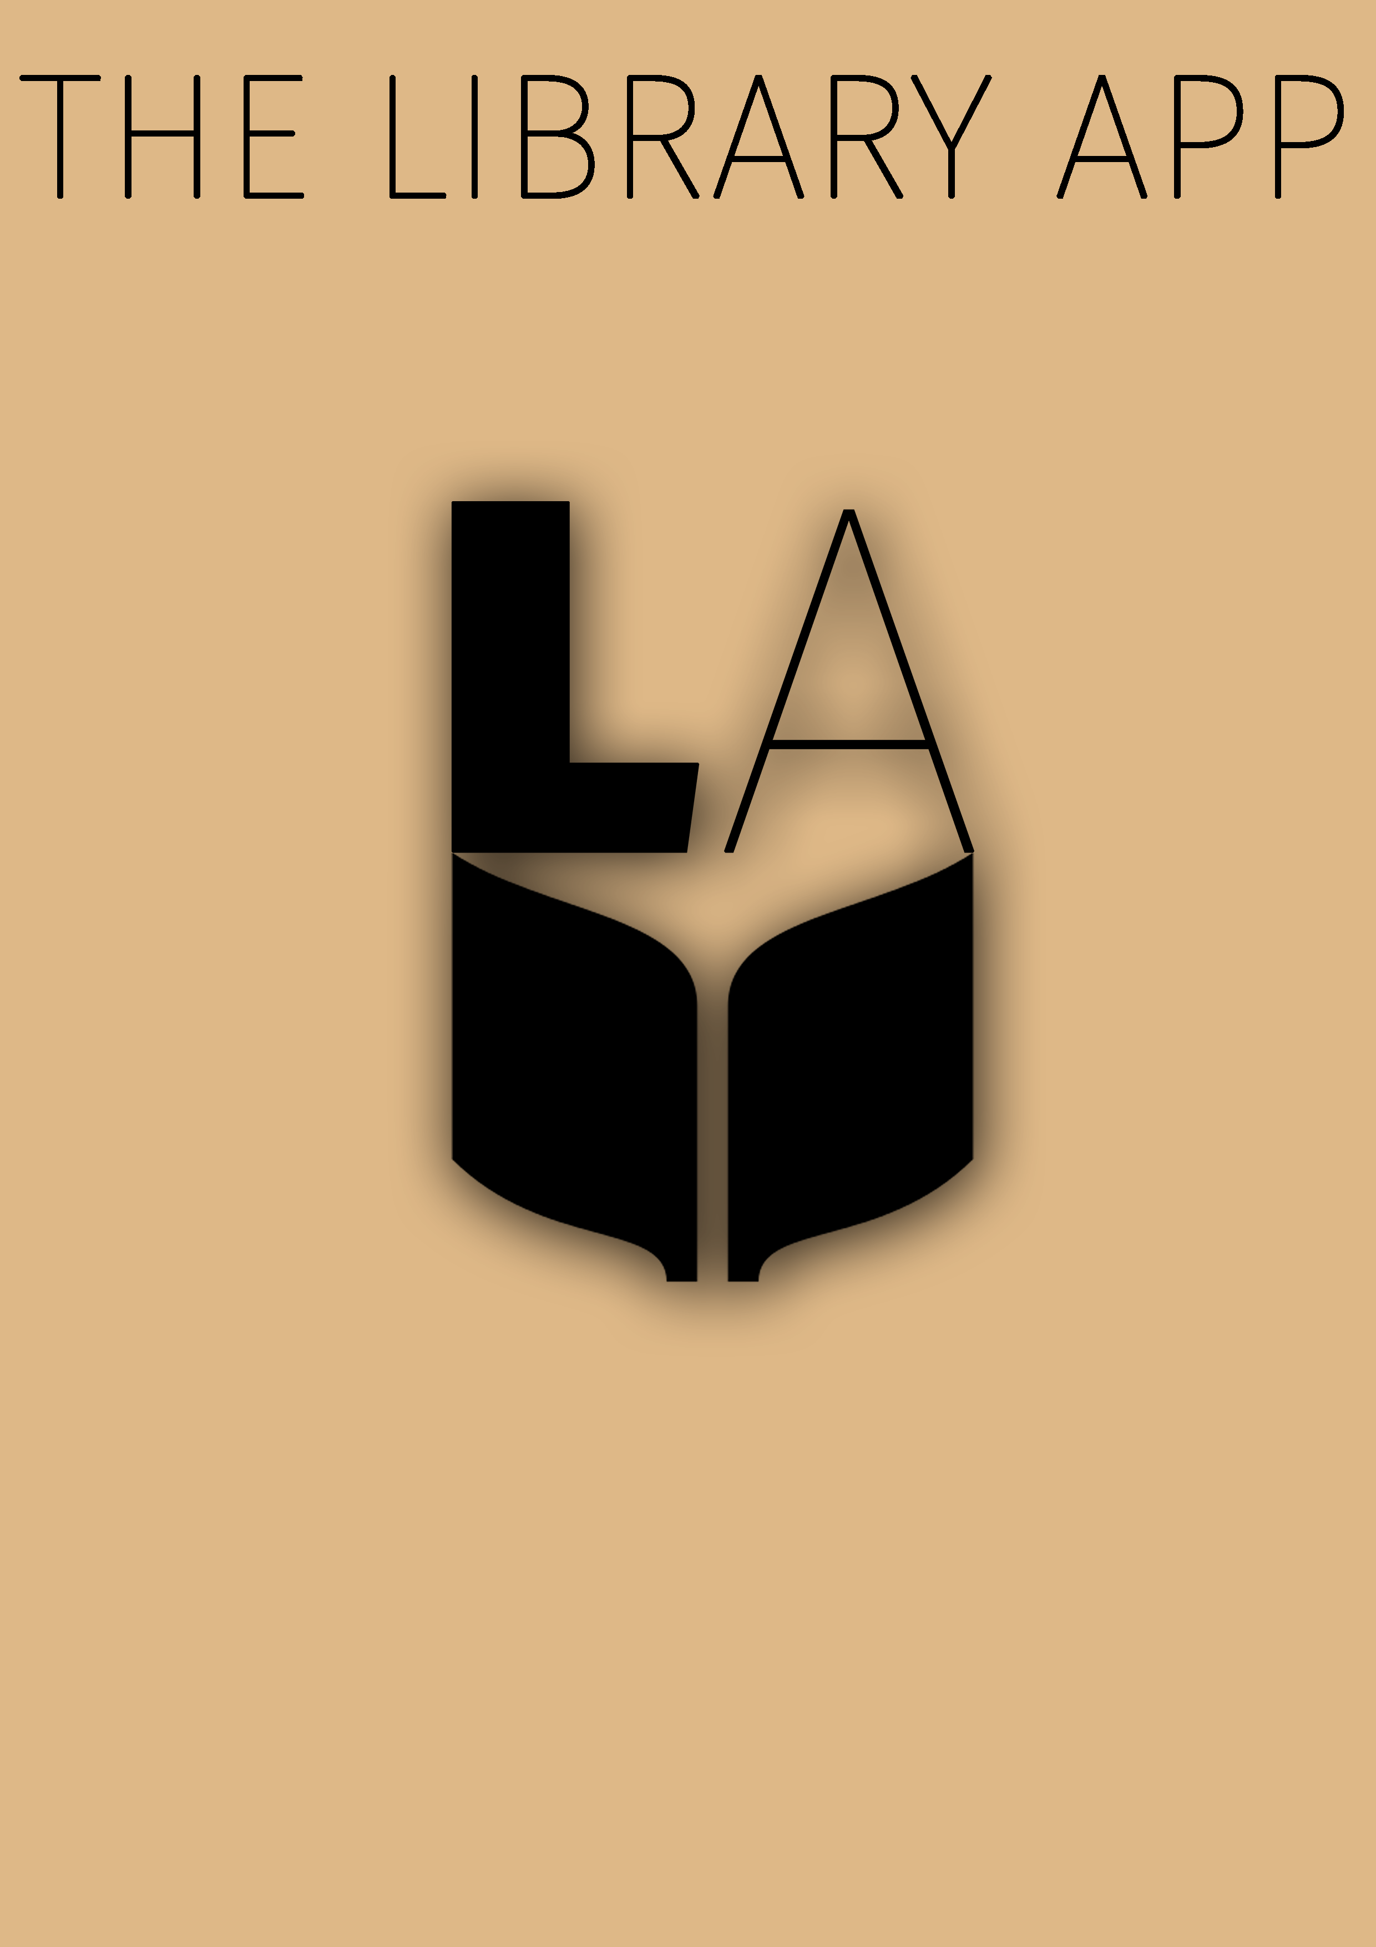Table of Content

1. Abstract
2. List Of Figures

1

2

3

4

5

5

6

7

8

9

10

# 1. Introduction

## 1.1 Problem Specification

## 1.2 Solution Outline

## 1.3 Application/Usage

# 2. System Analysis

## 2.1 Existing System (If any)

## 2.2 Software Requirement

## 2.3 Hardware Requirement

# 3. Design and Methodology

## 3.1 Flowchart of App

## 3.2 Output (Screenshot of the app)

## 3.3 Limitation of App

# 4. Conclusion and Future Scope

5. References

**ABSTRACT**

The idea of our app arose from a small library that opened up at our group member’s building. He wanted to provide a simple user interface to interact with the library in an efficient way as well as provide utility. Our app focuses on two main things: simplicity and minimalism. We believe both these concepts are very important in making an app that is easy to use but useful to access. We have given our best in protecting these ideals by not cluttering the User Interface of our app with useless pictures or information. We have kept the app efficient, speedy and neat. The entire focus is on nothing but the content, but at the same time the content wrapped beautifully making the user want to use the app again and again. We sincerely hope that this app will truly be something the library of Dosti Acres will cherish and make use of for years to come and hopefully encourage us to push this app to other libraries across the city.

**List of Figures**

**CHAPTER NO. TITLE**

3 Design and Methodology

Fig3.1 Flow Chart of the App

Fig 3.2 Output

1. Introduction

One of our members DishantKaushik, has a small library in the confines of his residential building. He wanted to develop some kind of a software solution to the issuing and returning of books. So we came up with the idea of developing an app with real time updates of book return and book issue. Every building member would be able to see the books that are available, books that have already been issued and the date the book will be returned. This is our basic aim, to achieve a simple yet elegant way to provide information about the library.

1.1 Problem Specification

* We have a lot of libraries in our city to provide a lot of books.
* But a lot of times we suffer the problem of unavailability of the books and we don't know which book is available and when.

1.2 Solution Outline

We need an online server to maintain records of the books and members of residential building. We also need to generate a method to provide identification to users using their smartphones. The online server needs to be real time and lag free so that the status of each book updates on time and is readily available to all users.

The start of our app is to purchase an online server service and ensure it is capable enough to handle the load of a few hundred building members. Next we need to establish a method of QR code identification for each member so as to make the issuing of a book to a user by a simple scan of the QR code. The code should provide the link in the database to all of the user’s information.

* 1. Application/Usage

# Features:

* Accounts for every user registering for a particular library.
* The user can check the availability of the books ,if it is available ,it can tell you where.
* If the book is not available ,it can tell you when it will be available ,and notify you when it is available.
* All you have to do is set a Wishlist of your favorite books and the app notifies you when it is available.
* When you are in the library, you can issue the book through the app itself. No need to fill up information in the file.
* Once you have issued the book ,the app also reminds you when the due date of the book is near.
* The usage and target audience for this app is only the residential society of Dosti acres.
* We set up a server which contains the information of every book in a particular library with its availability.
* This availability is set by the administrator of the library.
* When the user searches for the book that is unavailable, and adds it into the Wishlist ,we set a flag in the app ,so if the book becomes available,the flag is raised and the user gets notified.
* During the issue of the book ,the app generates a QR code for the administrator which contains the user ID.
* The administrator scans the barcode of the book and the QR code of the user ,and an entry to the database is made which contains the user ID ,book ID ,and the time and date of the issue.
* We will also calculate the due date and set a reminder in the users phone.

# 2. System Analysis

# 2.1 Software Requirement

The software required for the current application is

1) Minimum android version 2.2 (Froyo).

2) Preferred android version 5.0.2(Lollipop)-for material design implementation.

# 2.2 Hardware Requirement

The hardware required for the current application is

1) Application storage space 5 MB.

2) RAM requirement 35 MB.

3) MUST provide at least one soft keyboard implementation .It requires a proper working touch keypad.

4) Sensitive touch screen with minimum of 240 pixel width and 320 pixel height.

5) Minimum kernel version- Linux kernel 2.6.32.

# 3. Design and Methodology

# The design and methodology of our app is a simple responsive lag free user interface. We want our app to first serve the utility it is made for but also look beautiful enough for users to go back to it day after day for use.3.1 Flowchart of App

Start

Register

Login

Successful?

Yes

Select a book

Book List Menu

Available ?

Yes

No

Free to go and rent

End

Notify when available

# 3.2 Output (Screenshot of the app)

# C:\Users\abc\AppData\Local\Microsoft\Windows\Temporary Internet Files\Content.Word\Screenshot_2015-04-22-00-37-01.pngC:\Users\abc\AppData\Local\Microsoft\Windows\Temporary Internet Files\Content.Word\Screenshot_2015-04-22-00-36-48.pngC:\Users\abc\AppData\Local\Microsoft\Windows\Temporary Internet Files\Content.Word\Screenshot_2015-04-22-00-36-40.pngC:\Users\abc\AppData\Local\Microsoft\Windows\Temporary Internet Files\Content.Word\Screenshot_2015-04-22-00-36-18.pngC:\Users\abc\AppData\Local\Microsoft\Windows\Temporary Internet Files\Content.Word\Screenshot_2015-04-22-00-36-05.png

# 3.3 Limitation of App

The main limitation of our app is accessibility

to the internet. The app needs to connect to our server to access the user and book database. Without cellular network this is not possible.

# 4. Conclusion and Future Scope

If our App receives good response we would partner with other libraries in the city and release the app on Google Play Store. The possibilities of this app are endless as there are millions of people in the world love using libraries to read books.

**REFERENCES**

[1]. www.youtube.com

[2]. developers.google.com

[3] www.newboston.com